**Bootstrap Blocks**

Use only bootstrap classes to reproduce this page.

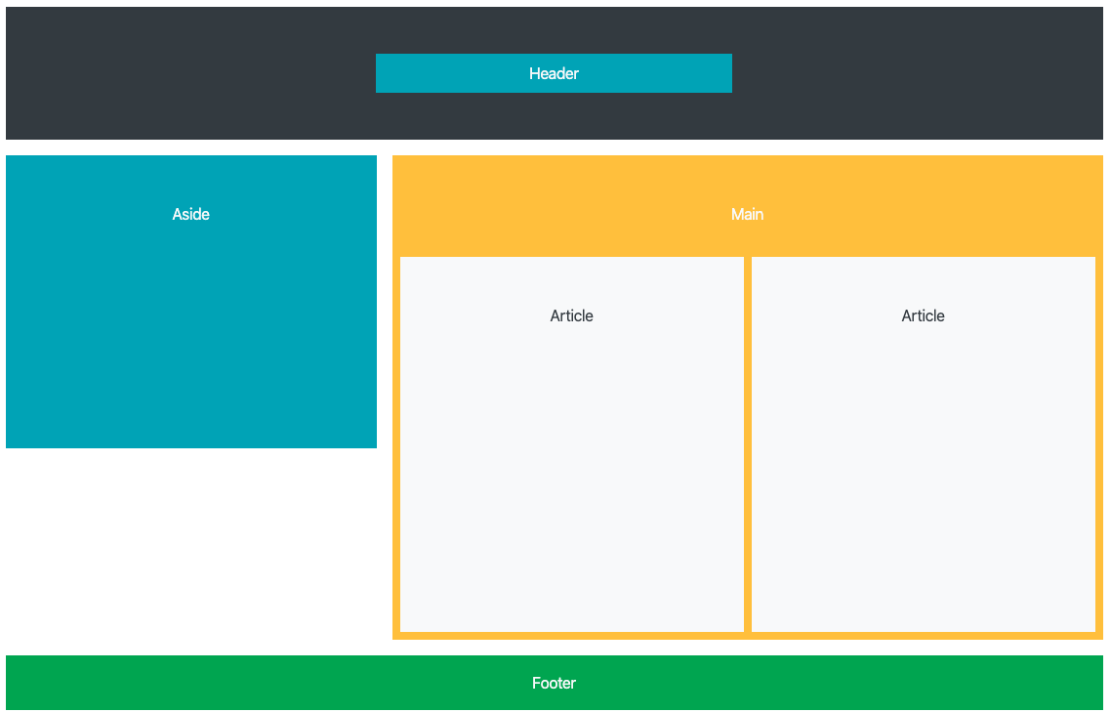

*<div>*

*<div>*

*<div>*

*<div>Header</div>*

*</div>*

*</div>*

*<div>*

*<div style="height:300px;">Aside</div>*

*<div>Main*

*<div style="height:400px;">*

*<div>Article</div>*

*<div>Article</div>*

*</div>*

*</div>*

*</div>*

*<div>*

*<div>Footer</div>*

*</div>*

*</div>*

Use the following classes for the assignment

* .col-{number, blank, auto}
* .row
* .bg-{color scheme}
* .p-{number} (paddings can be applied in a variety of ways see [docs](https://getbootstrap.com/docs/4.4/utilities/spacing/) for details)
* .m-{number} (same as padding)
* .text-{color scheme}
* .container
* .offset-{number}